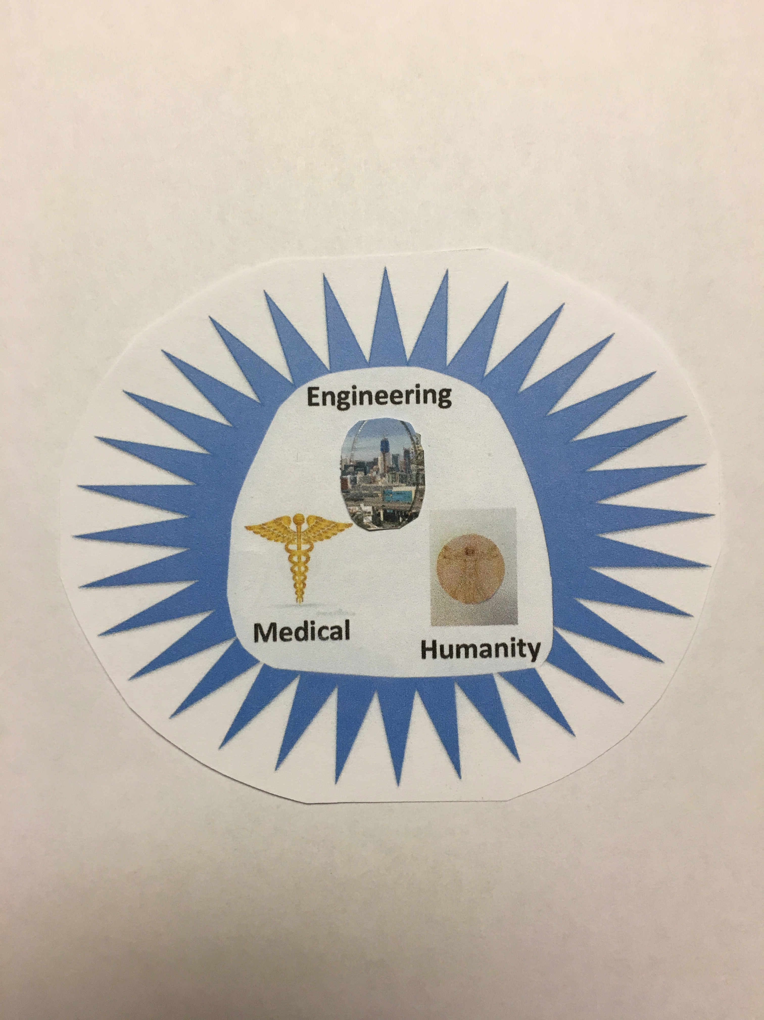

**The Thermosoma Device**

**An Engineering Approach to Immunotherapy**

***Providing Sustainable Health***

Table of Contents

Introduction 2

Immunotherapy 3

The Issues 3

Engineering Immunotherapy 4

Thermosoma Device Development 5

The Inventor 6

Relationship of Thermosoma Device to Congruent Approaches 7

Pranic Healing Approach 8

Who would use the Thermosoma Device? 8

Energies and Efforts for Sustaining a Healthy State 9

Sustaining Health after Thermosoma Therapy 10

Special Spiritual Provisions/Considerations 12

A Methodology for Establishing Control of the Body’s Master Control Center, the HPA and associated glands 13

References: 16

Attachments: 17

How is BAC valuable for slowing down brain aging? 17

# Introduction

*The engineering profession likes to think that the first civil engineer was a person who cut a tree to get across a chasm. Civil engineers have been felling trees ever since, to the point of irresponsibly harming the environment.*

*Similarly, from the beginning of time man has learned to survive by finding ways to heal his wounds and ailments. When a person got a cut, bruise, or minor ailment, they found things in nature to help their healing. As a result came the herbalist and then the pharmacist.*

*At some point in time, the health industry adopted the Hippocratic oath, the classic version including: “I will keep (the sick) from harm and injustice.” During this phase of time of environmental stress, the engineering profession has adopted a similar philosophy: Engineers are learning to "do no harm" to the environment.*

*It is amidst the challenges of science and pseudoscience that has developed the healing methodologies used by humanity to address the diseases and ailments that Roger Santos, the inventor of the Thermosoma Therapy Device, used the engineering design process as an approach that provides hope in activating, boosting, and strengthening the body’s own healing processes and systems. Roger’s knowledge, abilities, skills and experience using the engineering design process as a nuclear electrical engineer enabled him to understand the body’s living processes and systems. These subjects include electronic circuitry, control systems, feedback mechanisms, as well as thermodynamics, the gas law, and the properties of temperature, pressure, and time used by the engineering professions to properly design and construct engineering facilities. He has developed the engineering approach to immunotherapy by investigating the sum total of the healing modalities discovered by the medical profession that used the scientific method to develop healing modalities through chemistry, biology, surgery, and radiation.*

*The device that Roger has developed includes aspects of methodologies that are being successfully used by alternative therapy practices. The device is non-invasive. The therapy has few temporary side effects that are quickly handled by the body. The device simply activates, boosts, and strengthens the body’s own systems to heal itself: life systems that have developed over the time line of life and of the body’s existence.*

**There is an increasing effort to discover how the body’s own immune system could be used to attack killer diseases; that, perhaps the hypothalamus, pituitary, and adrenal axis (HPA) cluster of glands could be stimulated and boosted to perform its functions to protect and heal the body. Billions of dollars all over the planet are being spent in an attempt to activate patients’ immune systems “in just the right way-and early enough.” The development of immune-based treatments is being directed towards the biggest group of cancer patients with the disease in their breast, colon, lungs or pancreas.**

# Immunotherapy

**In principle, immunotherapy is a way to trigger the immune system’s ability to seek out and destroy invaders. It is how the body fights off bacteria and viruses. Thus, instead of using external forces, like a scalpel or radiation beams, the hypothalamus is stimulated, boosted and fortified to attack these cancers. The work on these therapies thus far has focused on developing some form of pill or IV; i.e., through chemistry.**

# The Issues

**In the meantime, all manners of diseases and ailments continue to be treated in traditional ways through prescription drugs, surgery, and/or radiation. Happily, many alternative health and healing methodologies are making inroads in achieving and maintaining health and wellness – including, but not limited to proper nutrition and diets, chiropractic procedures, herbs, acupuncture, acupressure, pranic healing, yoga, various other exercises and disciplines, massage therapies, and food supplements. Meditation and other stress relief techniques are also used.**

**Ironically, despite humanity’s efforts to activate the body’s immune systems, there is a countervailing practice of prescribing pain-killers to treat pain and suffering, the very signals required by the hypothalamus to mobilize its defensive and healing systems. Without these signals from throughout the body remotely connected to the hypothalamus, the hypothalamus cannot respond to the attacks of bacterial, parasite, virus, and foreign substances to which the body becomes inflamed and painful as a consequence to its intervention. Foreign intruders, cuts and bruises should be immediately detected by the nervous system sensors located throughout uncountable locations throughout the body that have developed over the many years of its existence. With the “pain killers” the immunotherapy ability of the body is neutralized and made ineffective. The body becomes numb; and, the ailing victims adapt and resign themselves to their unhealthy conditions. And, we have humanity living in quiet desperation in an unhealthy state.**

# Engineering Immunotherapy

**In the engineering profession, when a structure such as a house, building, bridge, pipeline, or freeway has reached a state of deterioration after which it is no longer useful, it is simply razed or removed to make way for another structure. A useful structure is a “living system” composed of heating, ventilating, and air circulation systems; its energy systems providing power for equipment, its waste discharge system, etc. Similarly, in the computer world, electrical, electronics, and computer engineers have provided powerful computing equipment to provide humanity with powerful external brains. The engineering of robotics may one day in the future lead us to replicate nature’s creation of ourselves.**

**Can we acknowledge that humanity’s current approach to achieving healing and health is not much more effective than the attempts of the robotics engineers in replicating our capacities and capabilities as a human body? It almost seems too simple to think that the HPA glands could be awakened and boosted to perform its protective and healing functions that have developed over the many years of its existence, with the nervous system perhaps being developed by nature over a period estimated at 500 million years. There should be no question that the hypothalamus is the most complex, efficient, effective and complete healing mechanism on the planet.**

# Thermosoma Device Development

**There are many problem-solving methodologies: the scientific approach, the Harvard Business School approach for solving legal and business problems, the military approach to preparing an attack on the enemy, Buddha’s Four Noble truths, and others. An engineering approach to finding the causes of ailments and diseases and developing a solution includes many of the characteristics of these problem-solving approaches – including the review of successful treatments and therapies such as those discovered by Pasteur and Fleming. The engineering approach includes the equations and design for thermodynamics, the gas law, fluid mechanics, electrical sensors, communication systems, waste treatment and disposal processes, and feedback loops. Numerous equations and procedures had to be formulated and correlated to the functioning of the human body to get an understanding of the hypothalamus and its roles and responsibilities. A device had to be invented to get the hypothalamus immune response system activated, stimulated, and boosted.**

**The knowledge, abilities, skills and experiences of engineers, however, did not naturally lead to the Eureka(!) moment of developing an immunotherapy procedure. On the contrary, there has been a common experience amongst “healing and health engineers” of special circumstances causing sadness and sorrow over decades and generations: they have had multiple family members die from the killer diseases of pancreatic cancers, heart diseases, bacterial and viral attacks, and other ailments. The burning desire to find solution(s) by these individuals was fueled by these painful and long-suffering experiences. This was the common, major, driving force of the individuals primarily responsible for the Engineering Approach to Immunotherapy and finding the supporting resources that have made the Thermosoma Device revolutionary as a medical therapy approach.**

**The engineering approach to immunotherapy can be described as using an electrical device to generate heat, applied therapeutically with pressure, for specific periods of time on inflamed, diseased and associated areas and systems; and, applied along the channels and vessels connecting these areas to the HPA. The amount of heat, pressure, and time is dependent on the unique body characteristics of the client on whom the therapy is being applied.**

**The HPA responds to pain, inflammation, itchiness, chills, intrusions of foreign objects such as slivers, pollen, ingested toxins, etc. The Thermosoma Device is applied at the location of these indicators and along the channels and glands connecting them to the HPA. This Device serves to activate, boost, and restore the HPA cluster of glands to perform their natural functions of protecting, restoring, and maintaining the health of the body.**

# The Inventor

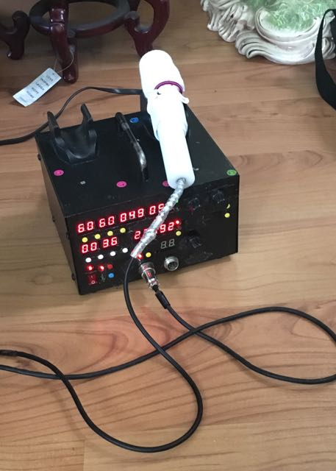**Roger Santos, a Nuclear Electrical Engineer, used the Engineering Approach to develop the Thermosoma Device. The Device has a patent pending and also has pending FDA approval. The Device is used to facilitate the flow of energy throughout the various systems in the body: the blood, the lymphatic, and the nervous systems with all its components including all the organs and glands – using heat, pressure, time, thermodynamic and gas laws, among others to remove blockages, constrictions, adhesions, and stimulating and boosting the HPA to restore/regenerate neurons and damaged cells. Over 500 clients have received therapy with 98% favorable results over the last five years for many of the almost 300 ailments, diseases, and maladies identified by the inventor upon which the Device could be applied. The Device is non-invasive. The probe is simply applied to the affected parts of the body to magnify the signals to the HPA. Success of a therapy is based on stimulating healing reactions by conjunctive systems in the body. Side effects have been found to include some temporary soreness of muscles and joints if time was inadequate for the client’s systems to have removed and discharged released toxins, dissolved plaques, adhesions, and other materials causing congestions and blockages. Relief from these side effects is achieved with the natural removal from the body of these materials through urination, defecation, perspiration, passing of bad air, and other drainages from the body’s openings.**

# Relationship of Thermosoma Device to Congruent Approaches

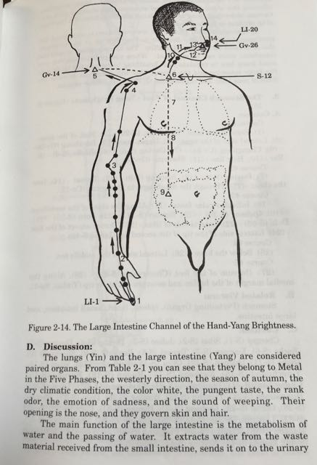**The Engineering Approach could be described as having evolved along traditional Chinese medical practices of acupuncture, acupressure, and Qigong massage developed over thousands of years in the battle of disease. Dr. Yang Jwing-Ming, a Mechanical Engineer, wrote in his book “Chinese Qigong Massage,” “some researchers use the theory of the body’s electricity to explain many of the ancient ‘miracles’ which have been attributed to the practice of Qigong. He further wrote “the method of healing known as the “laying on of hands’ could be an especially subtle form of electrical stimulation.” The Thermosoma Device could be visualized as enhancing or magnifying the effects intended by these practices.**

# Pranic Healing - 1Pranic Healing Approach

**The late Grandmaster Choa Kok Sui, a chemical engineer, established healing centers and foundations in over 80 countries through which practitioners teach and practice Pranic Healing. This is a step-by-step methodology of cleansing and balancing the bioplasmic body which contains the mold and blueprint of the physical body. Through the “laying on of hands”, the physical, mental, and emotional bodies’ ability to heal themselves are stated to be greatly accelerated. Through this acceleration, the life force or vital energy directed through the practitioner’s hands to the affected parts of the client is increased to promote healing. Pranic Healing is used to heal illnesses as they are still affecting only the bioplasmic body. The Thermosoma Device provides an electrical device that could enhance and/or magnify this approach. Work must be done to correlate the interaction between the bioplasmic and the physical body. The Thermosoma Device could then be called upon to address illnesses that have manifested in the physical body, where the hypothalamus and associated glands have the responsibility for its protection and healing.**

# Who would use the Thermosoma Device?

**The professionals practicing these “congruent engineering” approaches, because of their familiarity of the “engineering” control systems, and circuitry of the human body, and various functions of the organs and glands, could quickly enhance their practices with the Thermosoma Device. Many other health practitioners such as physical therapists and caregivers could add this tool to their practice and services. The simplicity of the Device and its use for common ailments and maladies could make it become a common household tool for restoring and maintaining the health of a family.**

**The aging baby boomers would directly benefit from the Thermosoma Device; as well as those who would take on the responsibility for their healing, health, and well-being – their children, relatives, caregivers, health workers and those responsible for the costs of caring for them.**

**The large number of people who have had only the option of taking pain pills and progressing to take opioids would benefit from the Thermosoma Device to find relief from the pains and discomforts of inflammations, infections, chronic and lingering illnesses and diseases that traditional medical practices can offer no other recourse.**

# Energies and Efforts for Sustaining a Healthy State

**All healing approaches can result in sustainable health only with the right foods that are introduced into the body and transformed into the energy forms that nourish the body. Various terms are used for these energy forms. But, ultimately, it is the energy from the Sun and stars that give life on earth and this single energy source is transformed into its numerous manifestations that are used to sustain life. In Pranic healing, major sources of foods are described as being solar, air, and ground prana. In Qigong, Chinese medical science classifies Qi energy as organ, channel, nourishing, guardian, and ancestral energies. The differences in these perceptions of energy forms and the differences in focus and goals help to define the results of these therapies.**

**The Engineering Approach made the assumption that the HPA cluster orchestrates the governing and Master Control Center of the immune system, healing, and maintenance functions of the body. Using this assumption, the engineering approach allowed a shift of focus from attempting to “manage” the various manifestations of the Sun’s energy to simply activating, nourishing, and boosting the HPA and associated glands to perform their naturally developed functions of protecting, repairing, healing and maintaining the health and well-being of the body. Humanity cannot hope to invent anything anytime soon that could be comparable to what Nature has created in the HPA. The Thermosoma Device was designed and created to be an external amplifier of distress signals to create conditions and an environment such that the client’s HPA is activated, stimulated, and boosted to mobilize and perform its functions of protecting, healing, and maintaining health that Nature has developed over the many years of the existence of life.**

# Sustaining Health after Thermosoma Therapy

**The Engineering Approach recognizes the necessity of the HPA cluster to receive the right food to sustain its functions. “Brain Chemistry,” by Dr. Michael Lesser, provides guidelines on the nutrition required to combat killer diseases. All other ailments could be avoided by greater attention on the right choices of the nourishment we select in addition to the food we eat; including, the fuels we use to nourish our intellect, our feelings, and our spirit.**

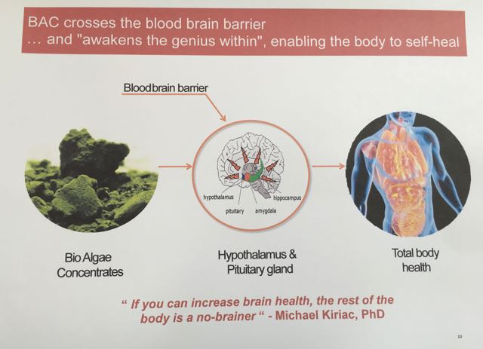

**Bio-Algae Concentrate (BAC) capsules bring to the hypothalamus the maximum amount of available energy by the transformation of the light energy from the Sun by algae. The digested capsule has the capability to pass through the blood brain protective barrier to reach the hypothalamus. These capsules should complement the best possible nutrition available to the client. The BAC complements the clients’ food intake to assure that the hypothalamus attains a maximum level to efficiently and effectively function to nurture, defend, and heal the body.**

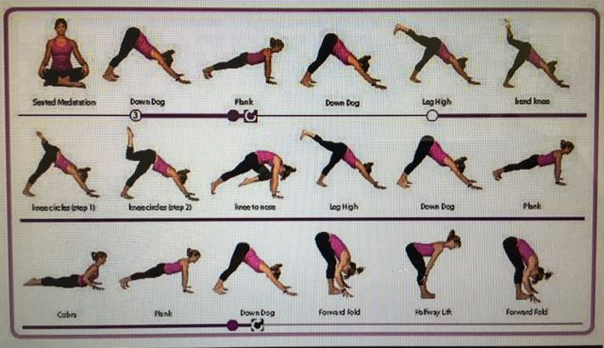**The goal of the Thermosoma Device should not only be to arrest the downward trajectory of health; but, after the therapy, steps should be taken by the client towards an active, more healthy, sustainable lifestyle. The Thermosoma Device shall relieve the client from the pains, discomforts, and threats to life; but, once these conditions have been arrested and improved, there must be efforts by the client to achieve a level of health to experience joy, happiness, and peace of mind. Practices such as yoga on a continuing basis should follow a therapy with the Thermosoma Device to reach a more conscious level of physical, intellectual, and emotional health that provides for an experiential and fulfilling life.**

**Dr. Marcus Penn, an MD, provides the higher purpose for which the Thermosoma Device enables us to awaken the apparent logical healing and health functions of the HPA; and, that is to lead the effort to educate humanity that the pressing ailments and sufferings that crushes the human spirit worldwide can be addressed with this Device. Dr. Penn has directed his life efforts towards a “Self Care Reform Wellness” for the community. This is an effort to make individuals become responsible for their respective health and well-being…. And the Thermosoma Device provides one tool with which to “Awaken the Universal Force Within” to provide a path towards attaining a higher state of being for all of us.**

# Special Spiritual Provisions/Considerations

**The success of any healing approach should consider the necessity of incorporating and fully tapping into the energies contained in belief – the energies of faith, patience, and love. These energies fall outside or beyond the realm of scientific, engineering, medical or other approaches in this material realm; but nevertheless, these forces exist and are essential for full success in any healing approach that is used. Ancient practices such as meditation, prayer, chanting, relaxation practices, music and aromatic therapies and rituals have effectively established great cultures and societies based on these practices. These practices and rituals have sought to connect humanity to something superior, above, or beyond our observation or comprehension.**

**The Engineering Approach to ImmunoTherapy makes the assumption that the HPA and associated glands serve as the seals to this something superior, above, or beyond our observation or comprehension. This cluster of glands can be considered, as previously mentioned, the Master Control Center (MCC) of our being. In the Engineering Approach, the Thermosoma serves to activate, strengthen, and boost this MCC.**

**But, then the approach must go further: the client is encouraged to take the role of the Captain of this MCC, just as the “Captain” of a cruise ship, and know that the MCC is his/hers to command. The client has to adopt the intention that it shall be his/her will, commands, visions, intentions, and purpose to direct the operations of the HPA to protect, heal, sustain, and evolve the physical being. There are many examples in every day life of how this can be accomplished and we need to simply become conscious of them.**

**Consider that the many sacred teachings provide guidance on how this is to be done….. the Buddha’s teachings on detachment and the Noble Truths and meditation, the Christian teachings including the one prayer taught by Jesus (the Lord’s Prayer) and the Sermon on the Mount, and Mohammad’s teaching of a single God. These are all the pathways towards getting control of and using the HPA, this most complex and effective bio-mechanism known to humanity. The HPA and associated glands are the result of what Nature has developed over the years of the existence of humanity and life. These functions and operations are far beyond the capacity and capability of our scientists, researchers, or others in the health industry to understand; much less to find substitutes anytime in the foreseeable future to the HPA in its limited abilities to nurture, protect, heal, and maintain our human life systems.**

**Belief, a composite of the energies of faith, patience, and love, is of great importance for the therapists to have, as well as for those helping and supporting the client: parents, relatives, as well as doctors and other healthcare workers. To assure greater success, the Engineering Approach must be performed with solemnity and sacredness to connect with these energies of belief.**

# A Methodology for Establishing Control of the Body’s Master Control Center, the HPA and associated glands

**We are the sum total of the nourishment from energies that begin from the sun, stars and the universe, eventually transforming to the food we eat, the air we breathe, and the impressions that impinge on our senses.  The variations of how our respective bodies metabolize these energies result in the different types, physically, intellectually, and emotionally among us during this particular existence.  We have primarily been a product of our environment over the many years of our existence.**

**Our sacred teachers along the way have guided us to continually make progress in discovering a soul or spirit or presence within us that could make changes in our material being to enable us to fulfill our intentions. Our intentions could be simply to just survive; or, these intentions could be grandiose to accomplish much.  Maslow, perhaps, provided the range of our intentions, more widely known as our Hierarchy of Needs.**

**Humanity is, perhaps, at a stage of its development to understand who or what has control of the factors that determine the conditions and pathways of our existence; especially those who have an awareness that there must be more meaning in life.  Thus, throughout history humanity has established rituals, prayers, disciplines, exercises, postures, invocations, meditations, and practices to take us to a better place.**

**Visualize now that our body is as a cruise ship with all its modern, complex power systems of propulsion, communication, hundreds of staff to operate the ship, to maintain it, to provide service to thousands of passengers. Now visualize that we are the Captain of the ship responsible for the journey of the vessel: we are in control of the intentions of the ship, the journey, the destination, the purpose, the existence of the ship.**

**The technique of Vichara (Self-Inquiry) followed by Sri Maharshi could lead us to discover our role through the question: "Who am I?" We can come to understand our role as "Captain" of our respective Master Control Center powering our material being, superior in all ways to anything humanity can attempt to invent, developed by nature to protect, heal, maintain, sustain, and adapt our material being to ALL possibilities. We can each consider as a tool what can be called “People’s Healing and Health”: a Passage to the Best Possible Quality of Life - a comfortable life with peace of mind towards finally achieving uninterrupted consciousness leading to eternal life.**

*Prepared by:*

*Jafilam M. dela Cruz*

*Manager, SVDNA, LLC (DVBE)*

*Registered Civil Engineer, State of California*

*Lt. Col., US Army Reserve, Retired*

*MBA, Mgt GGU, S.F. ‘77*

*BSCE, U.C. Berkeley ‘66*

*As Consultant to:*

*Roger Santos, Inventor*

*Thermosoma Technology, Sole Proprietor*

*B.S. Electrical Engineer, Mapua Institute of Technology*

*Former Nuclear Scientist with the Philippine Atomic Energy Commission*

# References:

“Chinese Qigong Massage (General Massage)” by Dr. Yang Jwing-Ming, 1992, YMAA Publication Center

“Pranic Healing” by Choa Kok Sui, 1990, Samuel Weiser, Inc

“The Brain Chemistry Plan” by Michael Lesser, M.D. 2003, A Perigee Book

“Awakening the Genius Within,” The culmination in Cellular Nutrition, by Roland Thomas, BSc, ND; Seventh Edition, April 2016 – formerly published under the title “The Magic of Bio – Algae Concentrates: The Life of Michael Kiriac

In Days of Great Peace,” by Mouni Sadhu, 1977 Edition, Wilshire Book Company

Article: “Awakening the Genius Within” by Roland Thomas

Power Point Presentation: “Quantum Brain Nutrition (Advanced Nutritional Support) in the Martial Art of Wellness”, with Roland Thomas, Naturopath

Roland Thomas Video narrating Power Point Presentation on “Awakening the Genius Within” **(**<https://www.youtube.com/watch?v=O6tFdY5xOuk> )

# Attachments:

# How is BAC valuable for slowing down brain aging?

The Bio-Algae Concentrates (BAC) formulas have been evaluated during 15 years of research with over 20 animal species.  BAC is composed of pure microalgae, a natural and safe source of thousands of naturally occurring nutrients including all minerals (such as calcium), essential fatty acids, vitamins, and many powerful carotenoids/antioxidants. The research demonstrates that BAC offers an effective dietary support when nourishing exceptionally well the cells of the hypothalamus, resultantly increasing the assimilation of the nutrients from the regular diet, ensuring better calcium levels, calcium regulation, improved immunity, protection against oxidative stress and cell damage, and slowing down the effects of aging. The nutrients in BAC are 100% bioavailable with zero toxicity. For example, the calcium in BAC has a net utilization ratio over 90%. With such high calcium utilization, the issue of excess unabsorbed calcium typically found with calcium supplements is avoided. In several animal studies, when incorporating BAC in the diet, calcium assimilation and cellular calcium activity was significantly improved, and osteoporosis was prevented. The completeness, balance and synergy of the thousands of nutrients in BAC make it a perfect food, “the culmination in cellular nutrition”, as documented in the book Awakening the Genius Within.  Consuming BAC on a daily basis increases performance of the hypothalamus, resulting in better performance of all metabolic processes in the body, thus slowing down aging and promoting better health.