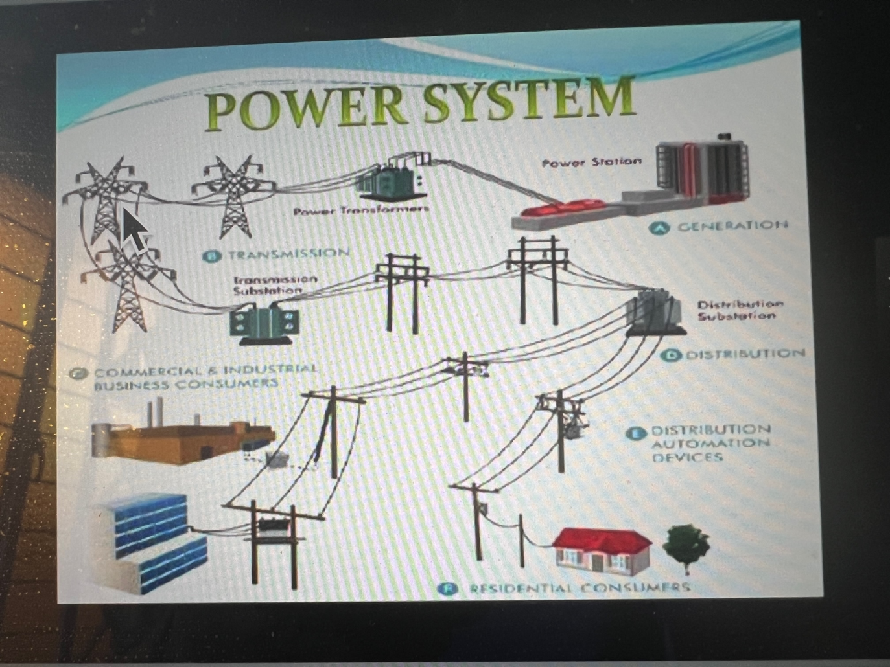

Electrical Power is generated at some **Power Station** located typically at some long distance from our homes and places of business at some very high voltage. The high voltage is conveyed through a **Transmission system** to local **Distribution systems** to provide electrical service to communities where **Transformers** reduce the voltage that can be used by our appliances, communications, and entertainment systems. Similarly, our **physical body** serves as **a transformer** for Divine Energy that is brought down through the recitation of the Lord’s Prayer.