(?) Source? From John’s meditation came images, symbols and forces.[1]

**CHAPTER KEYS**

**Chap 1 THE OVERSELF**

**CHAP 2 ENDOCRINE Healing – Lower 4 Glands (GONADS, CELLS OF LYDIG, ADRENALS, & THYMUS)**

**CHAP 3 PITUITARY, (Master Gland) HAS BOGGED DOWN**

**CHAP 4: Harmony Defined**

**CHAP 5***(Experience/Actions=>(Gravity/Magnetism)=>Flowers/Gemstones!)\*\*\***

**CHAP 6: Opening of 4 lower GLANDS through consciousness - regeneration of cells**

**CHAP 7 Four Intelligences Need Abrasion of Experience**

**CHAP 8 PITUITARY Opens 4 Glands to Recharge Entire ENDOCRINE SYSTEM**

**CHAP 9 Opening of THYROID (5th gland) & PINEAL (6th gland) Release Hormones and control given to Will**

**CHAP 10 OVERSELF Forbidden from Recording Until EXPERIENCED. Then told to Prophecy – To Apply.**

**CHAP 11: Collective Humanity Pattern – redemption of ALL Those who Acknowledge Divine as source of Healing and Supply**

++++++++++++++++++++

Chapters 1-11 describe the evolution of Individuals

vs

Chapters 12 - 22 describe the evolution of Humanity

++++++++++++++++++++

.

**CHAP 12 Rebellion of Cosmic Counter Balancing Rival Forces**

**CHAP 13 Unspiritualized Intellect falsely becomes symbol of success (How to SPIRITUALIZE?)**

**CHAP 14 CHRIST PATTERN[2] Achieves Supply Thru Self-Control**

**CHAP 15 Emotional and Spiritual Integration comes from knowing purpose**

**CHAP 16 Instructions for Purification of Glands**

**CHAP 17 How Pituitary & Instinct for Survival has failed us**

**CHAP 18 Man-made ideals of patterns for self-gratification has bogged us down*.***

**CHAP 19 Merging into Community shall occur**

**CHAP 20 Rebellion Curtails Evolution until density of evolved souls incarnate**

**CHAP 21 PERFECTION EXPRESSED as Gemstones of 12 Tribes**

**CHAP 22 Body expresses Book of Experiences…Healing Path that Returns Us to Tree of Life => Perfect Order – Health and Supply and Regeneration…(Arrival at Perfect Order)**

**Chap 1 THE OVERSELF**

Jesus the true author of the book became the Christ who fulfilled the pattern of man’s evolution and then turned to redeem and reclaim the rest of the race...

First to have completed the entire human experience.

**We have an OVERSELF - an unchanging core of each of us , a super conscious mind.**

OVERSELF always survives physical death.

**7 churches** introduction make up the endocrine system where physical forces of body , the mental forces, and the spiritual all come together.

**CHAP 2 Endocrine Healing – Lower 4 Glands**

**GONADS:**

“Has left it’s first love.”  (It’s spiritual ideal – it’s purpose) Spiritual purpose of ability to have union with spirit lost and reason for covering private parts:  {As finally cleansed in Mother Mary and shown by Virgin birth?}

A need for cleansing and purifying the forces of GONADS. (Propagation of species)

***{GONADS - Chap 2: 7 Epheus – “He that hath an ear, let him hear what the Spirit saith unto the churches; “To him that overcometh will I give to eat of the tree of life, which is in the midst of the paradise of God.”} {Interpretation: John is told that anyone who can regain control of this center could bring about his body and mind, as well as in his worldly circumstances, complete restoration of the law of healing and supply}***

Purpose to regulate and guard against destructive activities and pursuits, but purpose has been lost... now animalistic function, instinctual but without intelligence.

Regaining control of gland(**S**) results in COMPLETE RESTORATION OF LAW OF HEALING AND SUPPLY AND GROWTH.

———-

**CELLS OF LYDIG OR LYDEN GLAND** is center of IMAGINATION: pure energy from gonads take form here. Purpose of **SUSTENANCE** **or IDEALS** generated here in **conjunction with PITUITARY**. The “unregenerate”*** cells of **CELLS OF LYDIG or LYDEN GLAND** thwarts and limit activity are eliminated by purification.

**{¿HOW ARE CELLS REGENERATED?** Can Device ? Or, is there a spiritual component?}

***{CELLS OF LYDIG OR LYDEN GLAND - Chap 2: 11 Smyrna: “He that hath an ear, let him hear what the Spirit saith unto the churches; He that overcometh shall not be hurt of the second death.”} {Second death – regression from partial regeneration, broadly, a relapse}***

**ADRENALS** – **SELF-PRESERVATION** when 7 centers work properly hormones are released from **ADRENALS** - Spirit can renew and recreate self at will with hidden manna.

***{ADRENALS – CHAP 2: 17 PERGAMOS: “He that hath an ear, let him hear what the Spirit saith unto the churches; To him that overcometh will I give to eat of the hidden manna, and will give him a white stone, and in the stone a new name written, which no person knoweth saving he that receiveth it”.} { Hidden manna – impact of Spirit upon the endocrine system which releases its secretions into the blood stream, creating energy; white stone – higher development, new stage of consciousness}***

————-

**THYMUS** - (**SEAT OF SELF-GRATIFICATION**) persistence of this center to **misuse divine forces for personal satisfaction**. Disintegration and decay can occur... Jezebel - misdirection of creative forces.

***{THYMUS - Chap 2-29 THYATIRA – “He that hath an ear, let him hear what the Spirit saith unto the churches.”}***

Look at controls and motivations of each center to bring balance and true to perfect pattern to become complete master of environment.

**CHAP 3 UPPER THREE GLANDS**

**THYROID** - SEAT OF HUMAN WILL- **true function has been lost.**

**Overcoming temptation** will have perpetual access to the Creative Forces.

**{THYROID – Chap 3 – 6 Sardis – “*He that hath an ear, let him hear what the Spirit saith unto the churches.”}***

**PINEAL** - seat of all memory and record... urged to remain true and bring experiences into comparison with perfect pattern within the Soul... devil’s advocate?

In possession of entire soul record of all his experiences in the earth.

***{PINEAL – Chap 3-13 Philadelphia – “He that hath an ear, let him hear what the Spirit saith unto the churches.”}***

**PITUITARY HAS BOGGED DOWN:  “I would thou art cold or hot, not lukewarm:”**

**Must enrich itself through living , vital experience**

***{PITUITARY – Chap 3-22 Laodiceans* – “*He that hath an ear, let him hear what the Spirit saith unto the churches.”}***

**BECOMING ENRICHED COMES THROUGH LIVING, VITAL EXPERIENCE TO GAIN IN PERCEPTION AND AWARENESS.**

**Advice for all glands to return to original purpose**...

**Individual must open the door!**

**CHAP 4: Harmony Defined**

CONDITION OF COMPLETE HARMONY:

(Rainbow round about a throne as about an emerald as looking like a jasper and a sardine stone){Attributes of the Overself, like healing}

A mental awakening occurs after knowledge of endocrine system: OVERSELF COMES OUT AS A GUIDE - the point of control of the entire body-mind.

Below the OVERSELF are

- The 5 senses

- THE 24 cranial nerves (four and twenty seats) which are the lesser control points of the 5 senses; and then,

- the 7 glands (seven lamps of fire)

Then are the STILLED EMOTIONS - allowing OVERSELF TO RULE / orchestrate THE **4 LOWER CENTERS** (**FOUR BEASTS** **ARE DESIRES**) OF:

THYMUS- **Self- gratification** (eagle-can rise above the whole thing) air

ADRENALS-**Self- preservation** (Lion - preservation) fire

LYDEN - **Sustenance**(man) water

GONADS-**propagation of the species** (calf – creative, propagative force) earth

**CHAP 5***(Experience!)**

Real knowledge is sealed in the endocrine system: **average person has not the ability to open.** (Exposures, influences, guidance must be consciously tailored to get correct Resultant Vector: “No one comes to me except that He who sent me **draws him**…”

Only development of **Christ consciousness** (contained in Sermon on the Mount?) THRU EXPERIENCE*** WILL ENABLE THE OPENING OF THE CENTERS: ¿COVENANT? OF BUILDING A HOUSE ON ROCK?

Development is to have Lower centers and senses acknowledge control by the OVERSELF- (the self-Conscious, individualized portion of God, which is the unchanging core of each entity, the super conscious mind.) => the **PITUITARY / PINEAL** COMBO?!

The **THYROID** WILLS ITSELF TO BE SUBJUGATED / BE IN HARMONY WITH THE WILL OF THE DIVINE... which is found in **MEDITATION** ...

**There has to be death of the selfish-self, or self-will in the regenerating**, Christ-conscious man

**CHAP 6: Opening of all glands through consciousness - regeneration of cells**

Old ideals must be swept away with all material attainments and limited concepts. These are buried in matter avoiding correction by the forces of the OVERSELF AND THE REGENERATING WILL.

**GONADS**: Opened by forces of regeneration

**ADRENALS**: Main source of physical energy capable of galvanizing body into action

**LYDEN**: Spiritual gifts - price / penalty for misuse of each gift CHOICE

**THYMUS**: Ravages of degeneration shown through loss of consciousness and feelings of guilt as a result of self- gratification of body

**THYROID**: Disclosure of latent power, immobilized by misuse - have to wait for regeneration of other cells which are in the process of being refined

**PINEAL**: Accompanied by body trembling (?) and loss of consciousness with life essence centering only in the subconscious, with loss of mental impulses to the physical.

(**4 horses are FORCES THROUGH 4 lower glands**: **Gonads** – white horse; **Lyden** – black horse; **Adrenals** – red horse; **Thymus** – pale horse)

**CHAP 7 Four Intelligences Need Abrasion of Experience (4 angels)**

The **4 CONTROLLING INTELLIGENCES** of **physical, mind, emotions, and soul are now observed**

12 tribes at the individual level are the 12 systems of the body. At the level of humanity they are the 12 types.

**Cells are spiritualized with the perfect pattern of the** **CHRIST PURPOSE** **(Matthew 5, 6, 7 - Sermon on the Mount(?))**. Whole body regenerated and realigned with the ruling force of the Christ consciousness.

Cells become perfect through purification and regeneration thru **ABRASION OF THEIR EXPERIENCES**, without breaking down...the result is a continuous contact with the law of supply...,

**CHAP 8 Pituitary Opens Glands**

The **PITUITARY** IS OPENED BY THE OVERSELF and the entire **ENDOCRINE SYSTEM** is recharged:

**GONADS** release hormones to purify organs.

**ADRENALS** remove conflicts with spiritual forces cleaning out old patterns of energy.

**LYDEN** corrects ideals.

**THYMUS** activity has partial loss of consciousness.

More upheavals shall result as a result of activity of three upper centers of **THYROID, PINEAL, AND PITUITARY**.

**CHAP 9 Thyroid & Pineal Release Hormones**

**THYROID** RELEASES ITS HORMONES...control of the ID, subconscious mind, area of repression, is given to the will and negative repressions are released. Painful feelings of old regrets and guilt feelings are released and strike only at cells with no pattern or program.

**PINEAL** activates latent energy retained in the four elements of John’s makeup for changes in the physical, the emotional, the mental and the spiritual as a result of the practice of what he has learned.

There continues a momentum in the misapplying of the God-Force...

**CHAP 10 OVERSELF Restrained from Recording**

OVERSELF in complete control with all the **ENDOCRINE CENTER** open.

But, John FORBIDDEN **to record knowledge since not ready for a complete understanding of his divine nature.**

Time shall be no more: (5th? vs 4th?) dimension: **“there should be time no longer”**).

Mere knowledge in “mouth sweet as honey” but is bitter in belly...made part of him by bitter experiences through **personal application**.

(**And after John went through the bitter experiences in the world through personal application; then “Thou must prophesy (apply)again before many peoples, and nations, and tongues, and kings.”)**

**{John, Chap 6 describes the challenge of awakening humanity to the relevance of the teachings of Christ as leading to “eternal life” with the Revelation being the blueprint to “build that house on rock”.**

**CHAP 11 Collective Humanity Pattern**

(The third woe comes) and the pattern of Collective man’s experience with the law of healing and supply is laid out... the whole race acknowledging God as the source of all supply and healing.

++++++++++++++++++++

Chapters 1-11 describe the evolution of Individuals

vs

Chapters 12 - 22 describing the evolution of Humanity

++++++++++++++++++++

**CHAP 12 Rebellion of Rival Forces**

A crown of 12 stars => 12 basic patterns of man:

Soul fully illumined and in control of consciousness - a great wonder; but, RIVAL FORCES OF SELF WILL OCCUR bringing about recurring periods of rebellion.

By Divine intervention, the child that is the conscious mind is taken into protective custody.

**AS A RESULT OF EXPERIENCE IN THE WORLD**, Duty of human mind is to control rebellious urges coming from the physical.

**CHAP 13 UNSPIRITUALIZED INTELLECT**

Humanity suffers from **unspiritualized intellect**that **appears** to bring about certain miraculous transformation (“his deadly wound was healed”) that becomes **“symbols of success**”... results in people taking control with no particular belief in a higher power, **who don’t actually know in what they truly believe...(“**shall worship him, whose name is not written in the book of life.”

However, bottom line is the law of **Cause and Effect that goes on perpetually and inexorably... (here is a trajectory of everything we do)**

**CHAP 14 CHRIST PATTERN (Sermon on the Mount, Matthew Chap 5, 6, 7?) Achieves Supply Thru Self-Control**

Focus shifts to collective mind of humanity, the 144,000 perfect souls (12 tribes, each having gone through the experiences of the other 12 tribes)

- experiencing Universal forces

- experiencing lower natures and the senses

**However, the new experience of God as the source of all supply is LIMITED TO THOSE who have exercised SELF-CONTROL.**

**Inevitably,** **the consequences of gratification of the senses breaks up as** **the FORCES FOR BALANCE IN THE WORLD SHOWS THAT HIGHER FACULTIES AND TALENTS SHOULD BE USED TO FOLLOW CHRIST PATTERN..**.. (Matthew Chap 5,6, & 7 “Sermon on the Mount) REALIZING THAT ONLY THE BODY IS BOUND...

EACH SOUL REAPS ACCORDING TO WHAT IS SOWN

**CHAP 15 Emotional and Spiritual Integration**

**The integration of emotional and spiritual natures become stable as a result of knowing Divine law or purpose**

**Point at which souls of individual are purified and tested on seven levels of consciousness...**

**All encounter the condition sooner or later thru experience of the FOUR LOWER CENTERS come across the PERFECT PATTERNS FOR THE FOUR LOWER CENTERS - conscience sees the discrepancies between perfect pattern and actual experiences.**

**FINAL STEPS OF INDIVIDUAL FOR PERFECT SERVICE - all guilt feelings which result from seven fold tests arise to cloud the mind for a period... purified to then achieve mastery of self.**

**CHAP 16 Purification of Glands**

**INSTRUCTIONS GIVEN FOR PURIFICATION OF GLANDS:**

**GONADS**: Physical diseases are misuse of sex forces

**ADRENALS**: Sapped energy

**LYDIG:** Shut off of powers of HEALING & SUPPLY

**THYMUS:** Misapplied Love is a consuming force

**THYROID**: Misuse brings penalties of self- will - stubbornness & bullheadedness

**PINEAL Level**: New beginnings possible.

Propaganda: conflict in world between Groups and government.

Completion is when institutions collapse and concepts and achievement are swept.

**CHAP 17 PITUITARY & LUST (ANIMALISTIC)**

**The PITUITARY REVEALS THE FATE OF LUST AS EXPERIENCED THROUGH THE EMOTIONS IN ALL PEOPLE. (LUST => animalistic function, instinctual but without intelligence?**)

**Controlling intelligence brought low by misapplication of spiritual forces thru lust.**

**Archetypes of lust and emotional forces of rebellion that feed it and keep it alive.**

**These emotional forces drawn from energies of mind centers , thus depriving or limiting normal supply for bodily parts.**

**The HIGHEST FORCES OF EVOLVING HUMANITY OVERCOME THE FORCES OF SELF, IN TIME, WILL FULFILL THE DIVINE PATTERN.**

**CHAP 18 Self-Gratification Bogs Down Spirit**

“BABYLON” Man-made ideals of patterns for self-gratification.

Divine energies taken over and used for selfish purposes.

The archetype for self-gratification will bog down due to the very complicity and intricacies of its own creation.

- Babylon the great is fallen.

- Divine nature is withdrawn from the archetype which is abandoned to its own destruction.

- Senses will record a sense of loss of stimulations and excitements; but adjustment to new conditions is called for.

- Man’s collective selfishness has drawn energy from useful bodily, mental, and spiritual functions.

**CHAP 19 Merging into Community**

As laid out in Chap 11 wherein John completes his experience in regeneration as an individual man **- so he laid out the pattern of Collective man’s experience with the law of healing and supply that finally takes place in Chap 19.**

Merging of evolved self with the OVERSELF shall take place in all.

The stamp of the Christ pattern is in the constant application of Divine truth.

**CHAP 20 Rebellion Curtails Evolution**

Archetype of Man’s continual rebellions, the self-willed intellect is confined for a time in the collective ID.

For a thousand years, only evolved souls incarnate in the earth: Renaissance? All in perfect balance. Perfect peace and harmony to Nature.

Then remaking souls bringing unsatisfied ambitions and desires => former conditions of imbalance.

Evolved souls are curtailed by unregenerate souls.

**CHAP 21 PERFECTION EPITOMIZED BY Gemstones of 12 Tribes**

**New heaven and new earth.**

**Wipe away tears, no more death, neither sorrow, nor crying, no more pain. It is done...**

**The glory of god and her light was like unto a stone most precious.**

Perfected state of consciousness.

SOUL RECORD OF HUMANITY WHICH CONTAINS TWELVE BASIC HUMAN PATTERNS IN TERMS OF RECORDED TIME, SPACE , AND MOTION:

The OVERSELF SPEAKING ON THE LEVEL OF THE **PITUITARY** OFFERS TO EXPLAIN JOHN’S RELATIONSHIP TO HIMSELF.

Mind is now divine in the perfection of control and is free of outside limitation.

**12 STONES (Zodiac)**

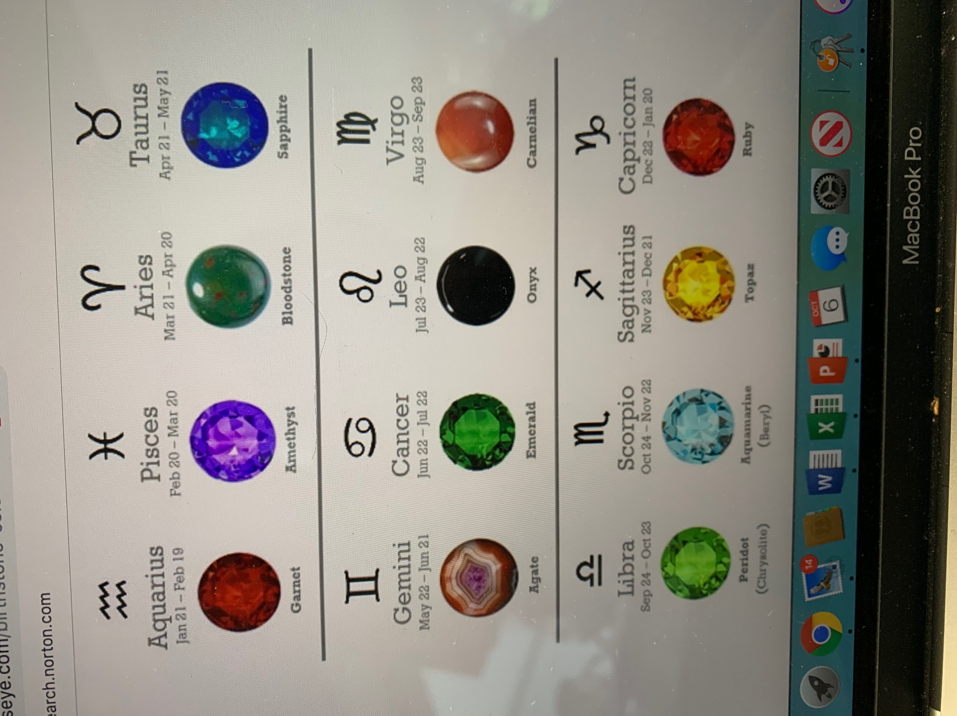

**CHAP 22 Body as Book of Experiences; Return to Tree of Life: Supply, Health, Regeneration**

**“Pure river of water of life, clear as crystal....”**

**“No more curse” “no night” “need no candles”**

**“Blessed are they that do his commandments, that they may have right to the *TREE OF LIFE…”***

***\*\*\*The “BOOK” is the body, which is the vehicle for human experience in the world.\*\*\****

**THE WILL OF INDIVIDUALS MERGE WITH THE DIVINE.**.. perfect order.

***Energy nourishes system for healing and supply in the physical and the age old limitations are removed and all is brought into perfect order.***

***TREE OF LIFE: FUNCTION OF SUPPLY, HEALING, AND GENERATION within THE SOUL.***

THRONE OF GOD - LAMB: PERSON IN COMPLETE SUPERCONSCIOUSNESS AS HIS NORMAL STATE

ANGEL: HIGHEST SELF

SPIRIT AND BRIDE: UNION OF OVERSELF AND PERSONALITY

***THOSE OPERATING WITHIN THE DIVINE LAW WILL BE IN CONTROL OF ALL HEALING AND SUPPLY FROM WITHIN AND/OR IN POSSESSION OF THEIR SOUL RESPECTIVE SOUL OR GOD CONSCIOUSNESS.***

**THE ENDOCRINE SYSTEM**

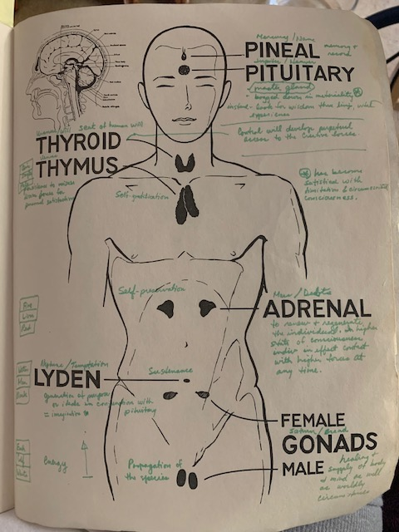

1. Prepared by: Jafilam M. dela Cruz, PE, Civil Engineer, State of California

   Principal Engineer, Retired, City & County of San Francisco

   LTC, Retired, USAR

   BSCE, UC Berkeley; MBA, Mgt, GGU, San Francisco
2. CHRIST PATTERN – “Sermon on the Mount” KJV Matthew Chap 5,6,& 7