**DEVELOPMENT OF ETHERIC, ASTRAL & HIGHER MENTAL BODIES**

**To Create**

**THE HUMAN ENERGY COCOON**

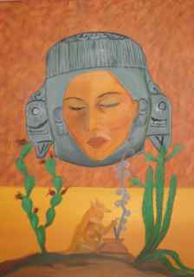

Transforming (Transmuting) Base to Precious Metal

(Painting by Lirio)

1. Develop **Permanent Center of Gravity** – Right Attitude, Valuation, & Realization

**Higher Mental Body**

***PERMANENT CENTER OF GRAVITY***

La 6

With sufficient intensity

Shock of Impressions

Shock of Air

**Etheric Body**

Si 12 –

Food Fuels Body

Mi 12 –

Fuels Emotions

**Astral Body**

Sol 12 – Air Fuels Mind

2. Work on Emotions: (Has to have intensity & speed)

1. Non-expression of unpleasant emotions; b. Non-identifying; c. Non-inner considering